GOLF CLUB FITTINGS

Why get a fitting with Flightscope? You get precise results detailing both what your golf club is doing as well as the golf ball after impact. The X3 machine uses both cameras and doppler to provide measurements that assist us in putting the right golf club(s) in your hands. Flightscope, Trackman, and Foresight are the most trusted launch monitors by tour professionals and club professionals.
Launch monitors can provide data to immediately improve your golf game. Minor reductions in areas such as back spin can increase carry distances by 10-15 yards.
Learn exactly how far you hit your golf clubs. Full bag fittings will help you pick the correct club with confidence as well as fill gaps between clubs particularly within your wedges.
Flightscope extends beyond just the driving range. It can be used for chipping and putting.
MEASURES
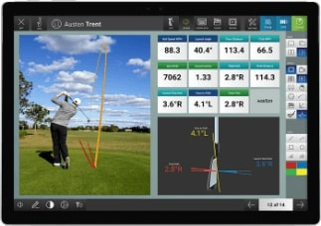
Roll Distance
Total Distance
Lateral Landing
Shot Dispersion
Shot Type
Face to Path
Face to Target
Club Path
Vertical Swing Plane
Horizontal Swing Plane
Low Point
Vertical Descent
Angle Curve

Ball Speed
Club Head Speed
Smash Factor
Carry Distance
Launch Angle
Spin Rate
Apex Height
Flight Time
Club Speed Profile
Club Acceleration Profile
Angle of Attack
Spin Loft
Launch Direction
Spin Axis

FLIGHTSCOPE FITTINGS
DRIVER-$35
WEDGES-$50
FULL BAG-$75

Add Flightscope to golf lesson-$20

